Backup Codes Maria Db
- 8eaafae651c7fe079e597d318fd53d51
- eedce4c4a7465e64b6615a5fa86af372
- 2ac27eb418654147b88b2a5029603e88
- 7590d77a90855a0e6d7fa4bf9880574f
- 96b04e8ddd5513cf69f12a030f457448
- 79c52f04c6156cb63f168bfeb35cf952
- 5cdf61e810a294753e7172c833b388dc
- 6213d35d069115411496f700550df3ec
- 1184c79a787656cfb4cf059bccf94683
- 54b473fd88b4db394ef452518af54b08
FresqlDatabase:

https://www.freesqldatabase.com:
armandbiham@gmail.com
Terasse&1982

Infinity : infinityfree.com
armandbiham@gmail.com
Terasse&1982
Domaine: medede.free.nf
Domaine passwort: V01r93I0wzdr3M
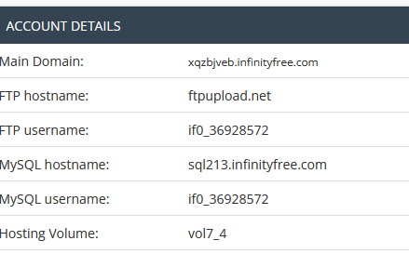
server:
port: 8088
spring:
datasource:
url: jdbc:mariadb://sql7.freesqldatabase.com/sql7720631
username: sql7720631
password: u9CfQv1x9d
driver-class-name: org.mariadb.jdbc.Driver
# url: jdbc:mariadb://localhost:3306/finanz_pilot
# username: root
# password: root
# driver-class-name: org.mariadb.jdbc.Driver
jpa:
show-sql: true
hibernate:
ddl-auto: update
h2:
console:
enabled: true # This enables the H2 console for easy database management (optional)
path: /h2-console # This sets the path for accessing the H2 console (optional)
tcpServer:
port: 9092 # This sets the TCP port for remote access to the H2 database (optional)
properties:
hibernate:
dialect: org.hibernate.dialect.MariaDBDialect
#twilio:
# account_sid: ${twilio.account_sid1}
# auth_token: ${twilio.auth_token1}

